***QUE-25.4-***

***TABLE CREATION & LOADING THE FILE***

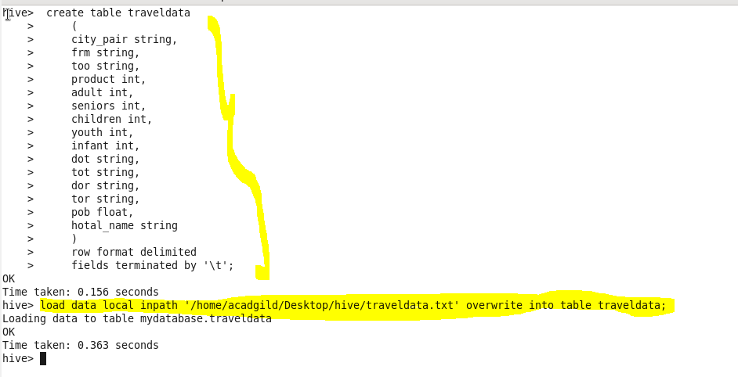

1. **Write a hive query to find the top 20 destination people travel the most: Based on the given data**

**COMMAND-**

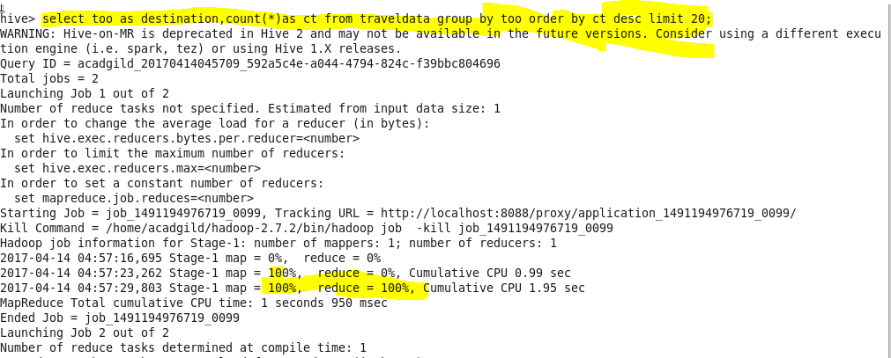

**OUTPUT-**

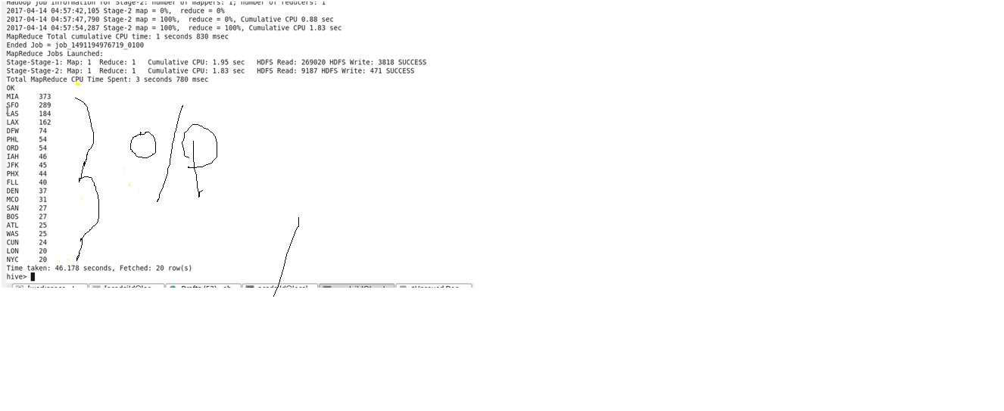

1. **Write a hive query to find the top 20 locations from where people travel the most**

**COMMAND-**

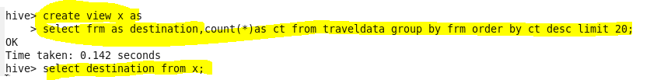

**OUTPUT-**

